IC-ENC Technical Conference (formally TEWG)

Dear IC-ENC Colleagues,

IC-ENC would like to invite you to send one delegate from your organisation to participate in the 3 day IC-ENC Technical Conference (TC01), which will be taking place from Wednesday 27th April to Friday 29th April 2016, at the Holiday Inn, Taunton.

IC-ENC will pay from its central budget for travel and accommodation costs, which will be booked by IC-ENC and the e-ticket supplied to you. This is limited to one delegate from each organisation; however, more than one delegate may attend the meeting if the additional expenses are met by your home organisation.

Please return the TC01 Attendance and Travel Arrangement Form which is attached to this letter. Please indicate whether you wish to attend, and if you do please also complete the travel arrangement part of the form.

Technical Conference:

The Technical Conference is an excellent opportunity for technical staff from all IC-ENC members to meet and discuss any ENC production/data capture issues that they face. It is a great way to build relationships and learn from colleagues with similar experiences in cartography to software usage. We openly invite attendees to submit topics for discussion or present to the group. IC-ENC also like to take this opportunity to ensure all our members are aware of recent developments and the assistance IC-ENC can provide.

Pen picture of attendee:

To assist in the selection of the appropriate delegate, please use the pen picture below and refer to the initial agenda for guidance. If you require any further assistance, please do not hesitate to ask. Please note the conference language will be English.

The delegate will likely be:

- Experienced in ENC capture and cartographic concepts
- Currently involved in ENC capture specifications and office standards
- Technical head of an ENC production team
- Knowledgeable and willing to participate in discussions
- Willing to disseminate knowledge back to home organisation

Flight bookings:

You are responsible for selecting your preferred flights. We would recommend that your flights arrive into either London Gatwick or London Heathrow. Additionally, those of you travelling within Europe may be able to arrive into Bristol airport.

Please refer to the provisional agenda (TC01 Technical Conference Draft Agenda) and timetable when choosing your flights. We recommend that you arrive on Tuesday 26th April, and depart on either Friday 29th or Saturday 30th April. Hotel accommodation will be provided from Tuesday to Friday. If you require additional nights this will be at the delegate’s expense.

Please note that all flights will be booked in economy class.

IC-ENC recognises that some delegates (particularly those from outside of Europe) may choose to arrange other meetings around this period in order to make the most effective use of the travel time. IC-ENC can be flexible in this regard with flight bookings but any additional costs will need to be paid for by the home organisation. Please contact me at the earliest opportunity if you have unique requirements.

IC-ENC will take all reasonable and practical measures to ensure a successful event, but each Hydrographic Office remains responsible for the ‘duty of care’ towards their representative. We recommend appropriate travel insurance is in place.

Visa arrangements:

It will be the responsibility of the delegate to apply for a visa if necessary. IC-ENC can provide supporting documents. Please ensure you apply with sufficient time for the documentation to clear.

Please follow the link below to check if you require a visa.
https://www.gov.uk/government/organisations/uk-visas-and-immigration

Hotel bookings:

Block hotel bookings will be made directly by IC-ENC. Details of accommodation will follow.
There will be a hosted event one evening which will be confirmed nearer the time.

Transport:

For your information, Bristol airport is about one hour away, and the London airports are about 3-4 hours away. Further information regarding transport to and from the airport/hotel will be provided nearer the time.

Please respond to this letter using the attached TC01 Attendance and Travel Arrangement Form by Monday 15th February. Responses should be emailed to me on Liz.Hahessy@ic-enc.org (cc: therenc@ic-enc.org).

I look forward to receiving your responses. If you have any further questions, please do not hesitate to contact me by email.

Kind regards,
Liz Hahessy
Future Standards Manager
Email: Liz.Hahessy@ic-enc.org

Attachment: TC01 Attendance and Travel Arrangement Form.doc
TC01 Technical Conference Draft Agenda.doc

Additional Information:

Taunton is the county town of Somerset, England located in the west of the country, with a population of approximately 64,600. It has a history dating back a 1000 years and is located close to the countryside in between the Blackdown and Quantock Hills.

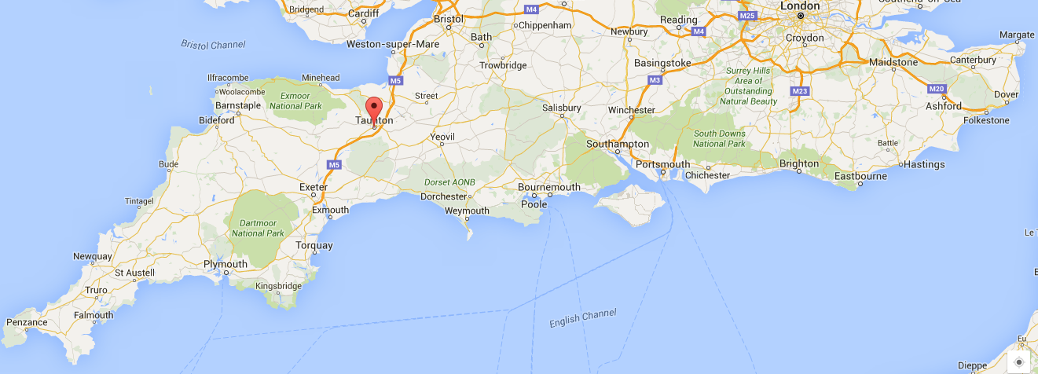

Weather:

Average temperature: 11°C with highs of 15°C and lows of 5°C. April is mid-Spring and can be a transitional month so please be prepared for rain and changeable weather conditions.

Plugs & Electricity:

Electricity is supplied from UK sockets at 240V and 50Hz. Please check your electrical devices to ensure they can operate at these levels or whether you require a transformer. The UK uses type G plug.

